Karela (Bitter Gourd) Recipe

Ingredients
- ½ kilogram karela (bitter gourd)
- 2 large onions
- Salt to taste
- ½ teaspoon garam masala
- ½ teaspoon red chili powder
- ½ teaspoon coriander powder
- Sundrop oil for frying

Instructions
- Wash the karela thoroughly and slice them.
- Sprinkle salt over the karela and let them rest to reduce bitterness. Rinse again.
- Heat cooking oil in a pan and fry the karela until golden brown.
- In the same pan, fry the chopped onions until soft.
- Add salt, garam masala, red chili powder, and coriander powder. Mix well.
- Add the fried karela back into the pan and cook for a few more minutes so the flavors combine.
- Serve hot.

Photo of Karela Frying
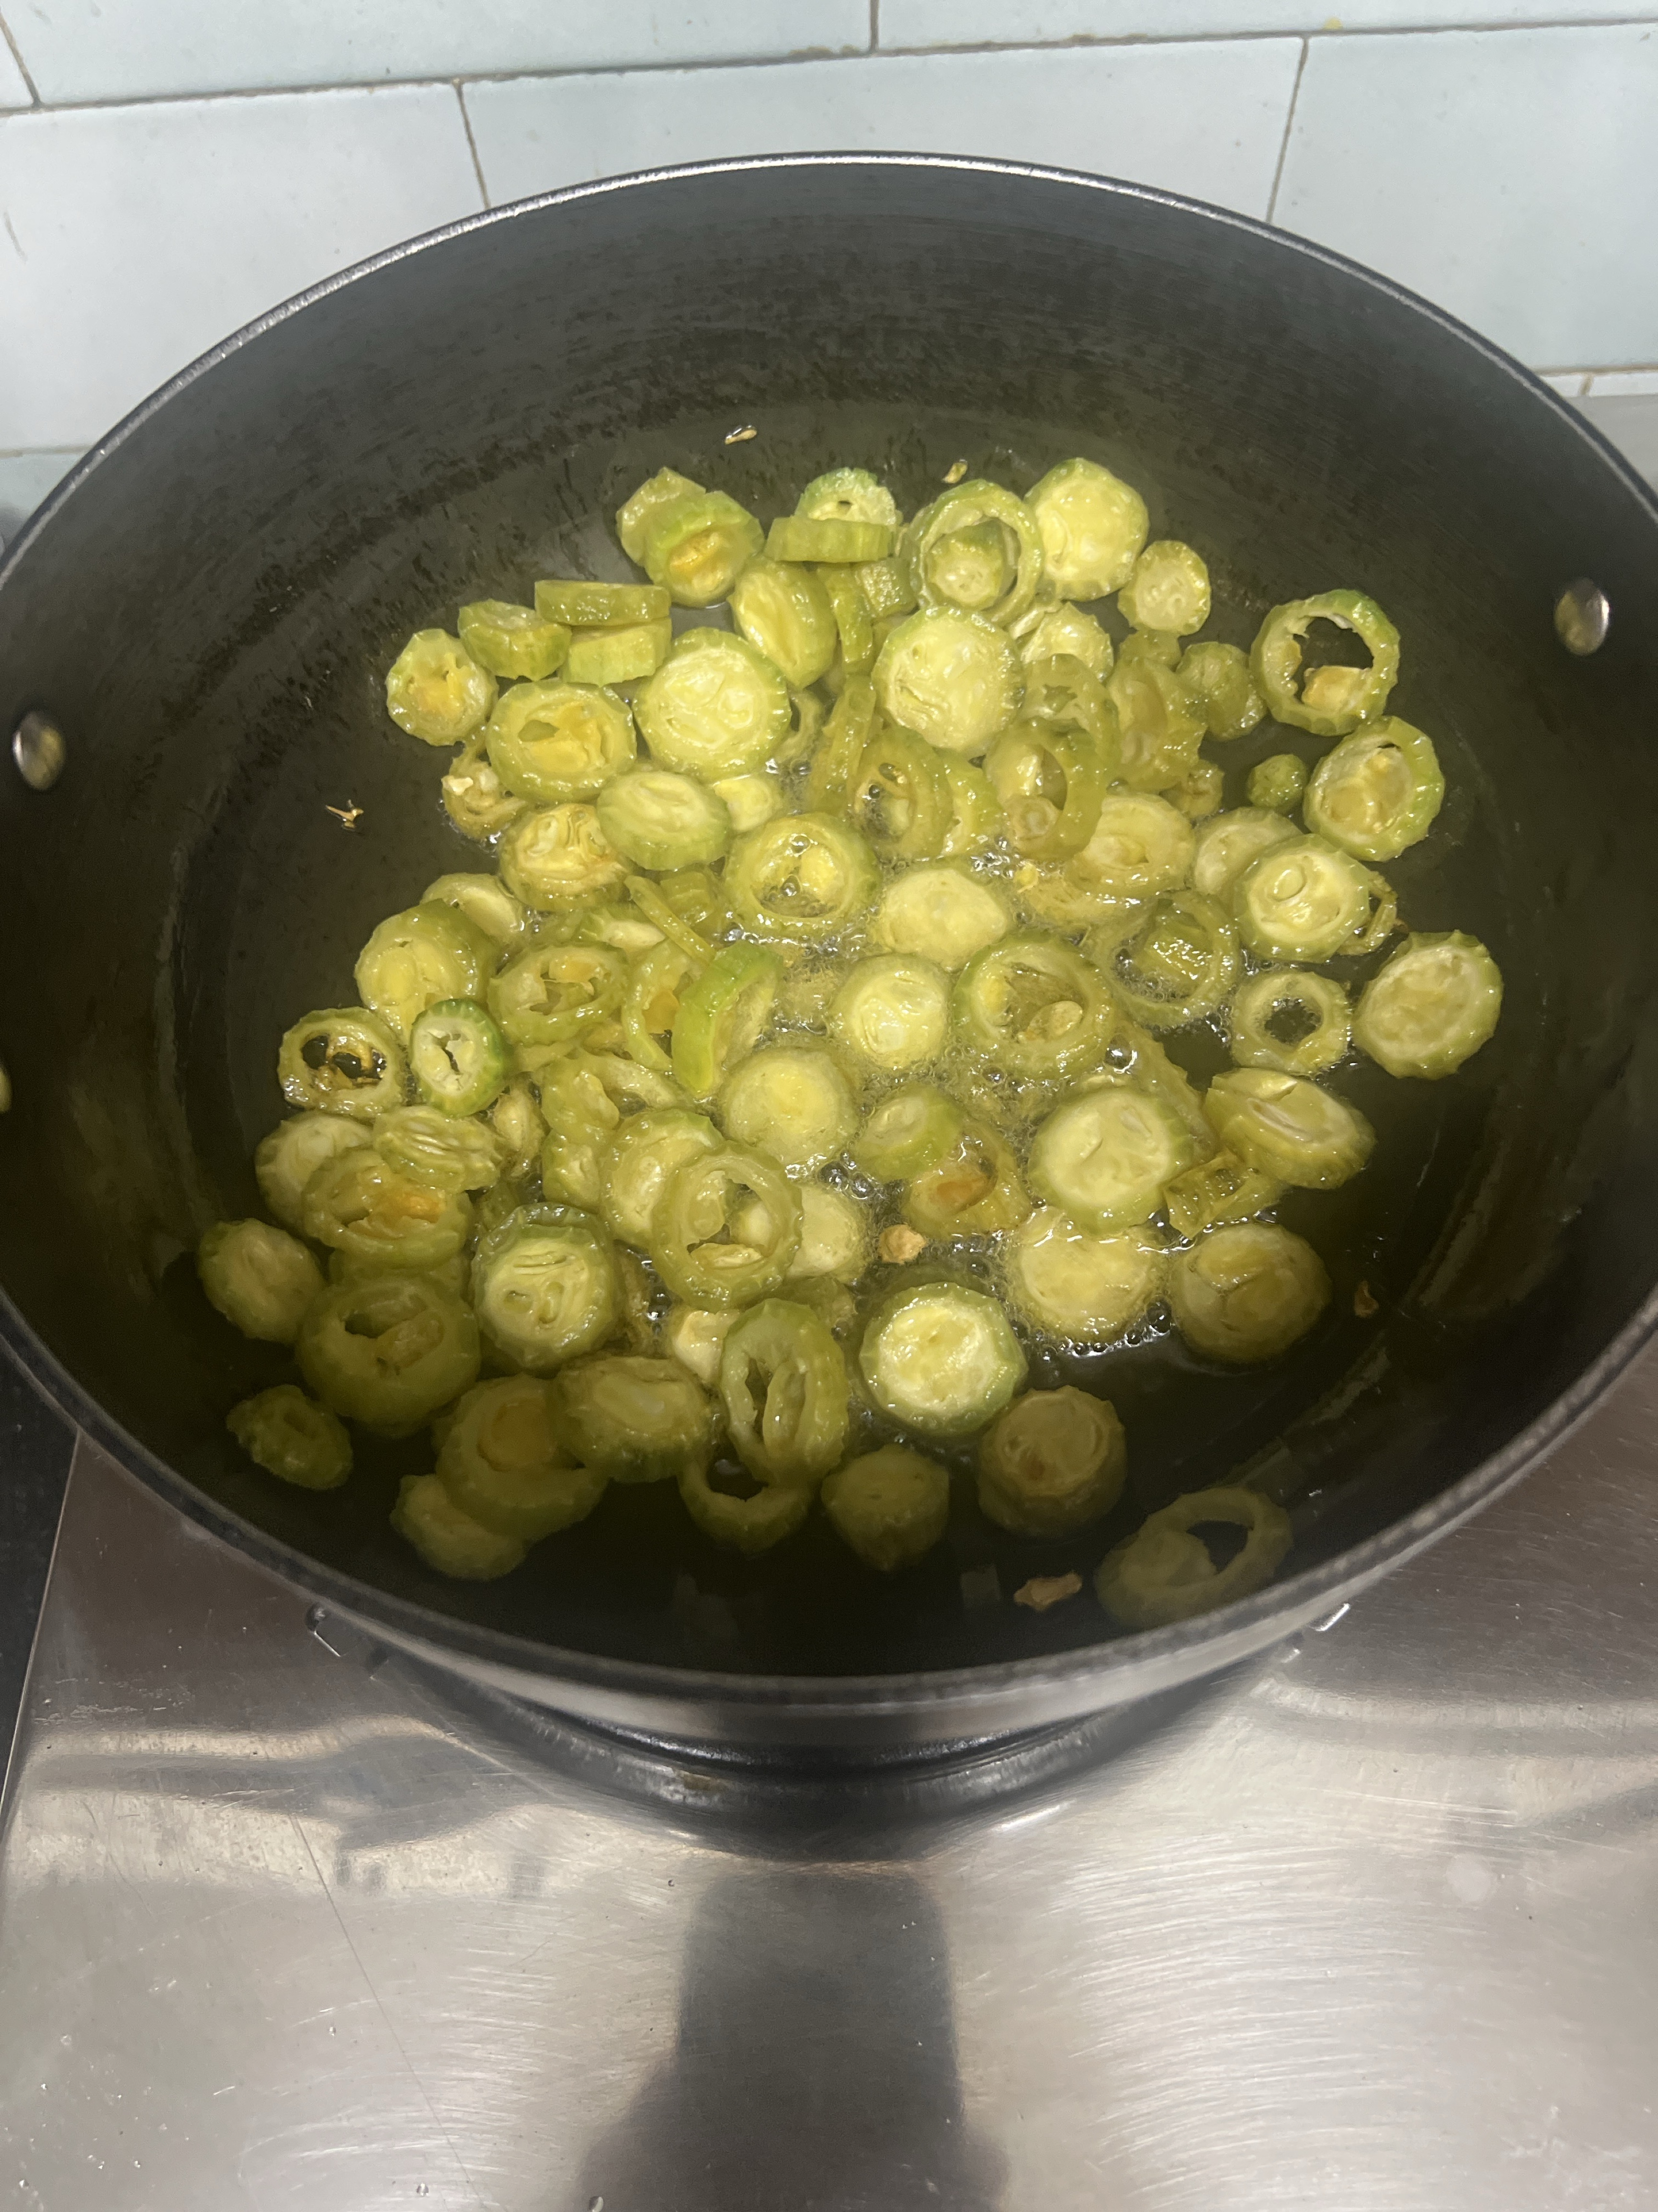

Second Photo (Fried Karela)
